https://www.youtube.com/watch?v=IySOT4QmRbY

Throwing the screenshots in here:
3D models:
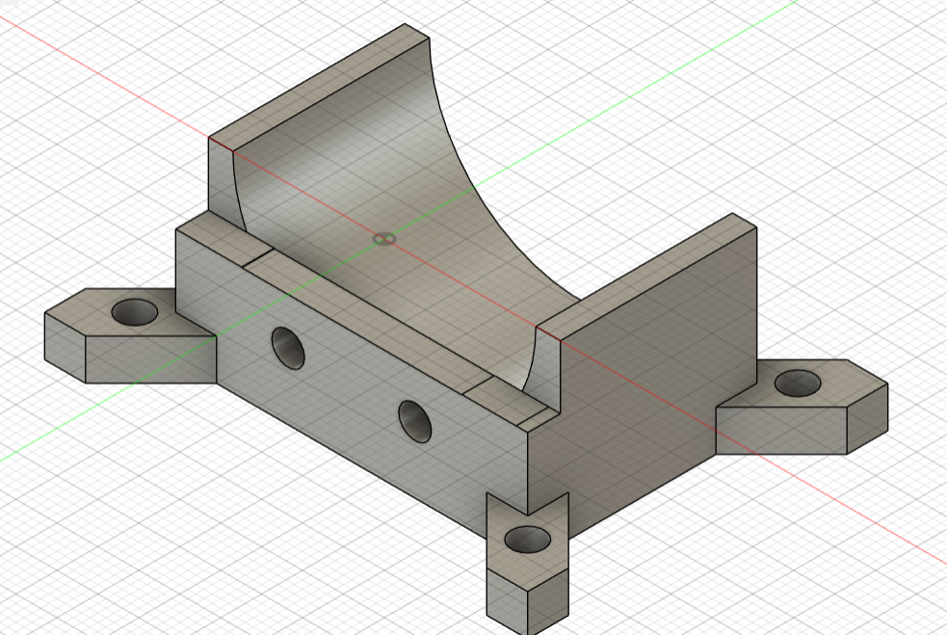
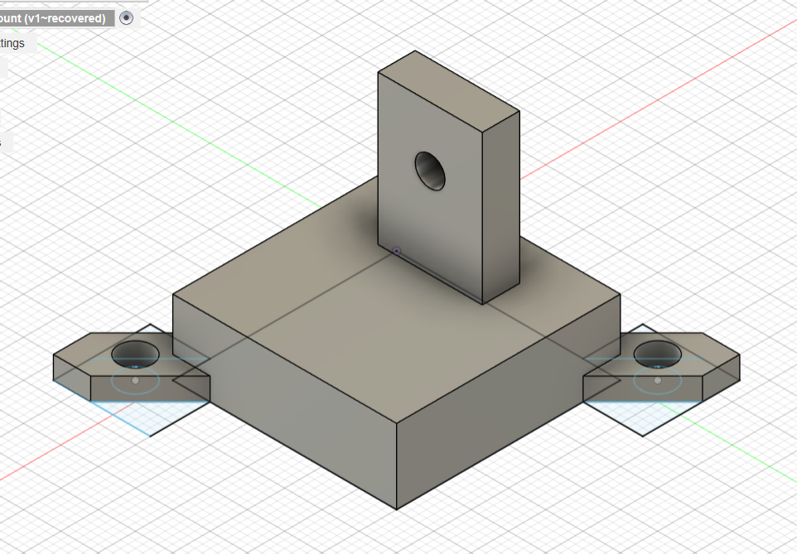
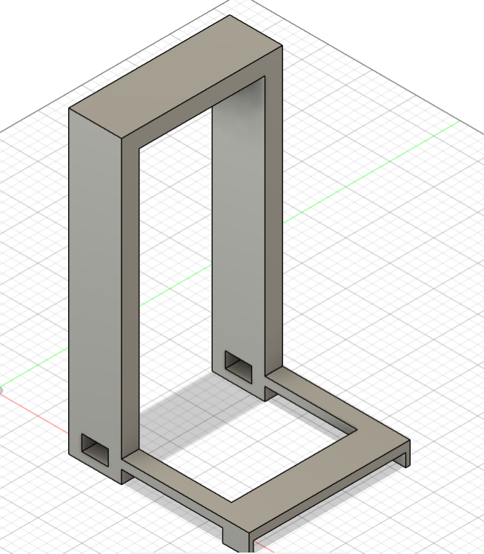
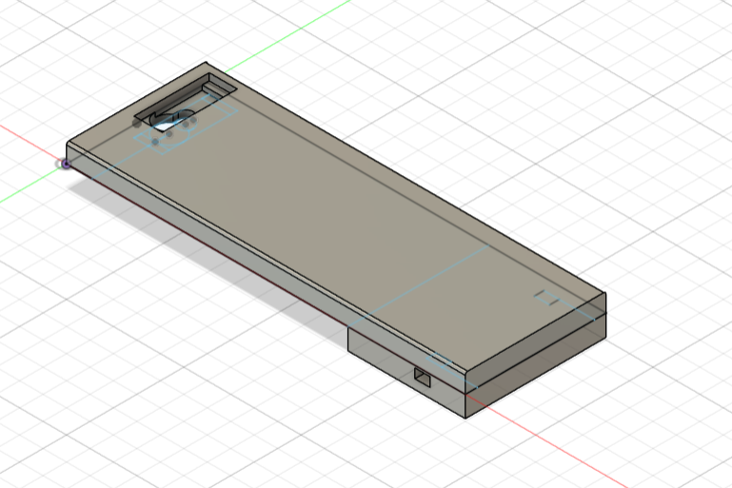
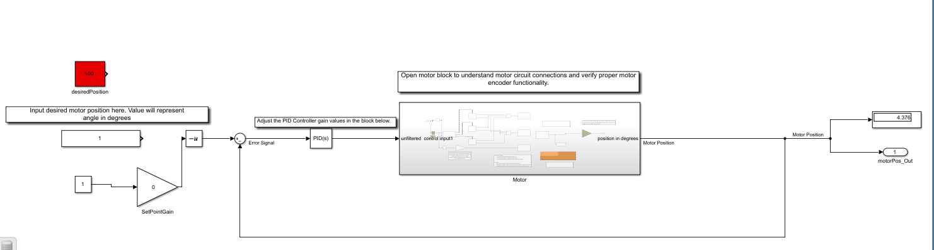
We don’t technically need the two blocks on the top left but I’m afraid of deleting them before the demo.

